REGISTRATION

Name_________________________________________________ Spouse______________________
Address________________________________________________________________________________________________________________________________ Practice _____________________
Telephone_________________________ Email________________________________ Class _____

REGISTRATION FEES After June 30th
CME registration only [paid membership required] ………………………$ 150 ……………..…... $ 200
Going to the ballgame Welcome Reception (WR) [per person] ................. free* ………………… free*
Alumni Filipiniana Night Dinner Dance [per person] ….........................… 90 …………………… 100
31st Annual Grand Reunion Dinner Dance [per person] .........................… 100 ………………….. 110
General Membership Luncheon (L) meeting [per person]…....................... 40 ………………….. 50
Annual membership ...................................................…………….…........ 60 ………………….. 60
TOTAL ...............................................................……......................….. $______ $_______

*For registered members and guests only.

To qualify for the discounted rate, register on or before Saturday, June 18, 2010. Mail this form and your check payable to “FEUDNRSM Alumni Foundation”,
c/o Oscar C Tuazon MD’⁷³ Executive Director
16025 East Gale Avenue, Suite B-10, Industry, CA 91765
Tel. (626) 336-6652
Email otuazonmd@gmail.com

CME registration fee is waived to alumni who are in training or waiting for training program, 50% discount for alumni retired from medical practice. Please present documentation for waiver or send letter from your program director. A service charge for $50 will be billed for checks not honored by the bank. A service charge of $50 will also be withheld for refunds/withdrawals. All refund requests must be made in writing on or before June 6, 2010.
The above-mentioned registration fees are required for everyone, including the Jubilarians and other Class honorees. Only the CME speakers and presenters are exempted from the CME registration.
Visit our website http://www.feu-alumni.com

Accommodation at the Troy Marriott Hotel

Log at stayatmarriott hotel.com, call (800) 228-9290, or (248) 680-9797
Rate: single or double occupancy $134 per day. Code name feufeua
Cut-off date is Friday, June 22, 2010

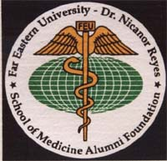

FAR EASTERN UNIVERSITY
DR NICANOR REYES SCHOOL OF MEDICINE
ALUMNI FOUNDATION

31st ANNUAL REUNION
& SCIENTIFIC CONVENTION

HONOREES
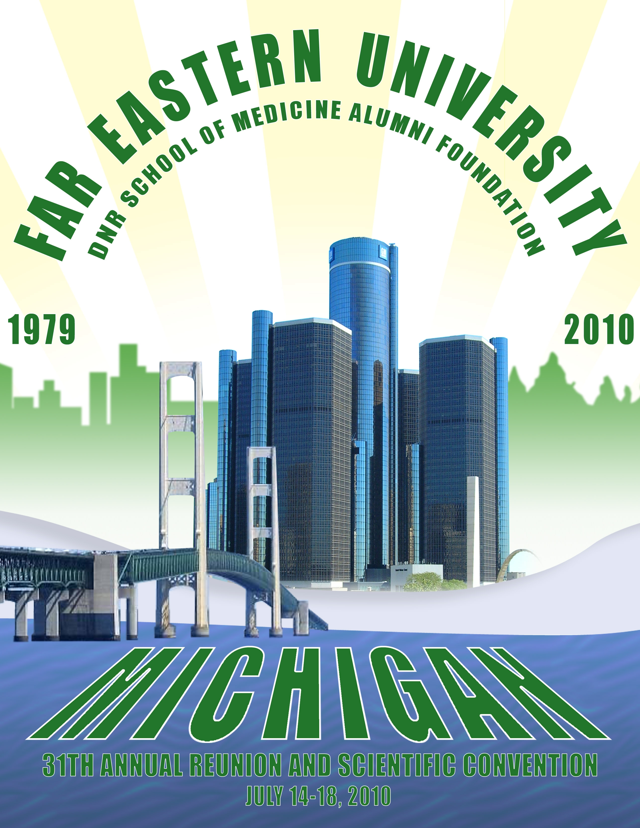
Class⁶⁰ (Golden Jubilee)
Class⁸⁵ (Silver Jubilee)
Class⁶⁵ (Sapphire Jubilee)
Class⁷⁰ (Ruby Jubilee)
Class⁷⁵ (Coral Jubilee)
Class⁸⁰ (Pearl Jubilee)
Class⁹⁰ (20th Anniversary)
Class⁹⁵ (15th Anniversary)
Class⁰⁰ (10th Anniversary)

CLINICAL PRACTICE ADVANCES 2010

ACCME accreditation provided by
the PHILIPPINE MEDICAL ASSOCIATION
in CHICAGO

July 14 - 18, 2010

Marriott Hotel Troy
200 West Big Beaver
Troy, Michigan 48084, USA
(800) 228-9290 or (248) 680-9797
FAR EASTERN UNIVERSITY DR. NICANOR REYES SCHOOL of MEDICINE ALUMNI FOUNDATION is a not-for-profit organization of 2700+ alumni physicians throughout the United States. Established 30 years ago, FEUDNRSM Alumni Foundation missions are focused on educational, charitable, humanitarian, community and civic services here in this country, in the Philippines, and at the FEU-Nicanor Reyes Medical Foundation Institute of Medicine (West Fairview, Quezon City).

ANNUAL REUNION: The first Alumni Foundation reunion was held at Marriott Lincolnshire (IL) during the 1978 APPA Convention alumni night. The event was so successful that our alumni decided to meet again every summertime to renew friendship, reminisce about the past, honor outstanding classmates, and have our families meet new friends. The New Jersey Chapter hosted the next reunion at the Playboy Great Gorge Hotel. In 1980, the first annual reunion with a scientific seminar was held in Orlando. In the succeeding years, the affair was held in Anaheim 1981, Boston 1982, Grand Island in Niagara Falls (NY) 1983, Indian Lake Resort in Chicago 1984, Orlando 1985, Virginia Beach 1986, Toronto 1987, Long Beach 1988, St. Louis 1989, Washington (D.C.) 1990, Atlantic City 1991, San Francisco 1992, Chicago 1993, New Orleans 1994, Las Vegas 1995, Minneapolis 1996, Dallas 1997, Anaheim 1998, Atlantic City 1999, Chicago 2000, Las Vegas 2001, San Francisco 2002, Norfolk 2003, Troy (MI) 2004, Las Vegas 2005, Houston 2006, Chicago 2007, Orange County 2008, and New York City 2009. The reunion has served as a venue not only to see our classmates, but also to present talents other than our medical expertise during the Filipiniana night and to plan activities for our annual reunion in West Fairview the following January.
SCIENTIFIC SEMINAR: Three comprehensive, accredited half-day programs that cover a broad spectrum of updates and current trends in medicine, designed not only for the primary practitioners but also for the specialists highlight the event. This continuing medical education activity has been planned and implemented with the Essential Areas and Policies of the Accreditation Council for Continuing Medical Education (ACCME), provided by the Philippine Medical Association in Chicago which is accredited by the ACCME to provide continuing medical education meeting for physicians and takes responsibility for the content, quality, and scientific integrity of this CME activity. It meets the criteria for 14 credit hours of the Category I ACCME Physicians' Recognition Award for the American Medical Association. The objectives of the scientific seminar are to offer a review of and an update on common medical and surgical problems, focusing on cardiology, endocrinology, infectious diseases, anesthesia, plastic surgery, malpractice, and miscellaneous topics of current interest. Since the CME meetings are held only in the morning, there is plenty of time for fellowship, camaraderie, and reminiscing for the rest of the day.
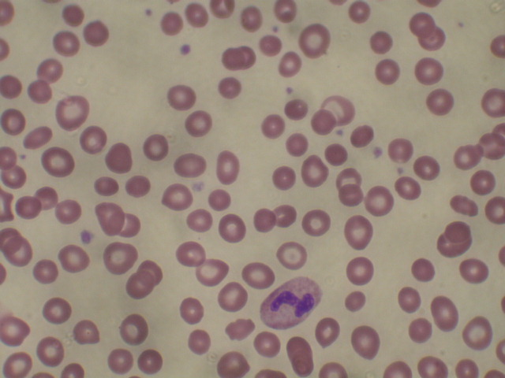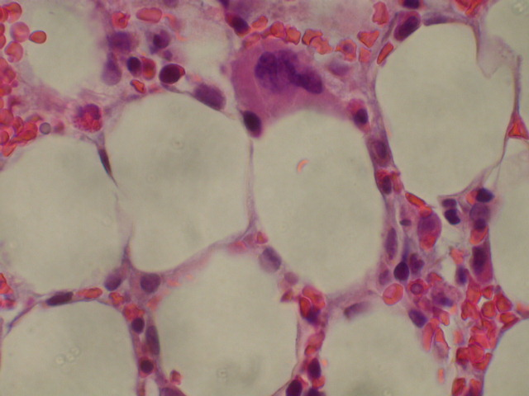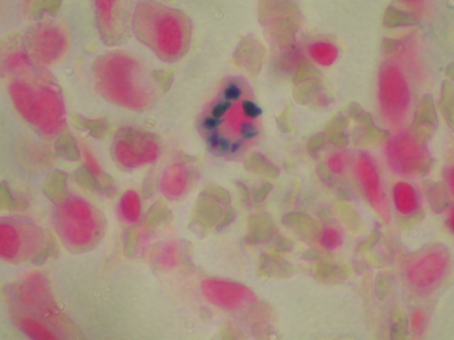
Figure 1 Figure 2 Figure 3

HONOREES: The honorees of the reunion in 2010 will be led by the members of the Class⁶⁰ Golden Jubilarians and Class⁸⁵ Silver Jubilarian. During the Grand ReunionSaturday dinner dance, the attending jubilarians are presented, first in slides the way they were in the medical school, then in person - the way they are now. The alumni night will recognize other honorees, namely: Class⁶⁵ Sapphire Jubilarians, Class⁷⁰ Ruby Jubilarians, Class⁷⁵ Coral Jubilarians, Class⁸⁰ Pearl Jubilarians, and Class⁹⁰ (20th anniversary), Class⁹⁵ (15th anniversary), and Class⁰⁰ (10th anniversary) celebrants. Members of these Classes are enjoined to attend in full force. If members of these Classes, or any Class, wish to have separate functions or to get together during the reunion, the Alumni Foundation will help with any arrangements. The more classmates you have, the merrier; however, the quality of your enjoyment does not depend only on your "old" friends and classmates. The enthusiasm and spirit of the attendees are generally infectious. The occasion, the place, and the company tend to your having a great time.
EXHIBITS: We have allowed pharmaceutical companies and specialty boutiques to have a show and display. To encourage artistic talents of our alumni, friends and families, there will be a museum/art exposition of their works (e.g. photography, water colors, oil paintings, etc), along with submitted abstracts for poster exhibit presentation.
CLINICOPATHOLOGIC CONFERENCE
CLINICAL ABSTRACT
Chief Complaint: Low back pain, pancytopenia and neuropathy
Clinical Abstract: A 39-year old woman presented with low back pain that progressively worsened for one year, paresthesia in the distal lower extremities that moved proximally towards the waist for six months, some tingling numbness in the hand for two months, and decrease in vision clarity. The patient denied mentation changes, motor deficits, and sensory ataxia. There was some urinary urgency during nights but not during the day. There was also no risk and features of HTLV/ HIV infection, tabes dorsalis, overseas travel, unusual pet and hobbies, toxin exposure, previous myelographic studies, lupus erythematosus, cardiovascular disease, cancer, family history of neurological disease, or previous blood transfusion. Over-the-counter zinc self-medication was taken regularly in an attempt to prevent upper respiratory infection.
Pertinent physical findings were normal vital signs and remarkable only for severe and impaired vibration and proprioception in both lower extremities, absent superficial abdominal reflexes, and normal sensation for touch/ pinprick/ thermal stimuli, brisk sympathetic deep tendon reflexes, absent pathologic reflexes, examination, and coins in her palm with eyes closed were identified.
Laboratory data revealed leukopenia (1,900 u/L) [Figure 1]; differential count of lymphocytes 86%, granulocytes 8%, monocytes 4%, eosinophils 2%, and basophils 2%; macrocytic normochromic anemia (red blood cell count 2,290,00/ uL, hemoglobin 4.9 g/dL, mean corpuscular volume 115 fL); thrombocytopenia (platelet count 173,000/dL); and blood chemistry values within reference limits.
Special studies included RPR for syphilis non-reactive; Epstein-Barr virus (EBV) capsid nuclear antigen antibody positive, EBV capsid antigen IgM antibody negative, and EBV nuclear antigen antibody positive; hepatitis A IgM antibody negative, hepatitis B surface antigen negative, hepatitis B core antibody negative, and hepatitis C antibody negative; HIV-1 and HIV-2 antibody negative; parvovirus B19 IgG antibody and parvovirus B19 IgM antibody negative; and rheumatoid factor titer and ANA screen negative; and urinalysis also within normal.
Magnetic resonance imaging of the cervical, thoracic and lumbar vertebrae demonstrated L5-S1 left paracentral disc protrusion and negative for spinal cord disease.
A right iliac crest bone marrow biopsy was markedly hypocellular [Figure 2], showed a few ringed sideroblasts [Figure 3], and vacuolated erythroid and myeloid precursors. The interpretation was suspicious for myelodysplastic syndrome with rare monoclonal stem cells and negative for paroxysmal nocturnal hemoglobinuria phenotype on flow cytometry analysis.
The cytogenetic analysis was a normal 46,XX female chromosome complement.

Your diagnosis? ________________________________________________________________________
Saturday, July 17, 2010
7:30 am - 8:00 am Registration, continental breakfast, exhibits

Cesar Jimenez MD⁷⁵, moderator
8:00 am - 9:30 am ClinicoPathologic Conference: Back pain, pancytopenia, neuropathy
Robert Arias MD⁰⁵ – Internal Medicine Resident
Edgar Altares MD⁸⁰ – General Practitioner
Remedios San Pedro Sales MD⁶⁵ – Internist Hematologist
Teodoro Manubay MD⁷⁰ – Radiologist
Raymund Razonable MD⁹² - Infectious Disease Specialist
Augustus Cezar Lastimosa MD⁷⁰ - Neurologist
Cesar V Reyes, MD⁶⁸ – Pathologist
9:30 am - 10:30 am Break, product, poster and alumni arts exhibits

Rossano L Bongasan MD⁸⁵, moderator
10:30 am - 11:10 am ADHD Update 2010
David Villanueva MD⁷²
Medical Director, DE Medical Center & ADHD Center Sterling Heights MI
11:10 am - 11:50 pm Introduction of Dr Nicanor Reyes Jr Memorial Lecture
Arsenio Martin MD⁶⁷
Chairman, FEUDNRSM Alumni Foundation
11:50 am - 12:30 pm 15th Annual Dr. Nicanor Reyes Jr Memorial Lecturer
Infections in Transplant Patients
Raymund Razonable MD⁹²
Associate Professor of Medicine, Mayo Clinic College of Medicine
Chair, Transplant Infectious Disease Program
Associate Chair for Faculty Development, Division of Infectious Diseases

12:30 pm - 3:00 pm Annual General Membership Luncheon Business Meeting
Hernani Tansuche MD⁶⁸, FEUDNRSM Alumni Foundation President
Arsenio R Martin MD⁶⁷, FEUDNSM Alumni Foundation Chairman
Oscar Tuazon MD⁷² FEU DNRSM Alumni Foundation Executive Director
Luzviminda Santangelo MD⁷⁷ FEUDNRSM Alumni Foundation Secretary
Grace Rabadam MD⁶³ FEUDNRSM Alumni Foundation Treasure
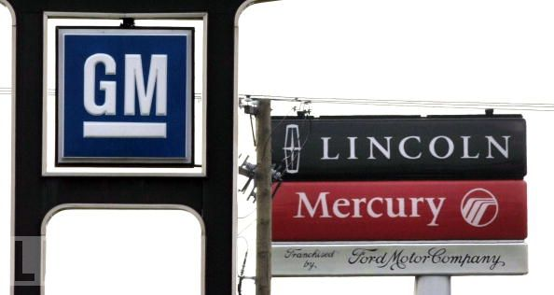
SCHEDULE of EVENTS

Wednesday, July 14, 2010
1:00 pm - 5:00 pm Registration
6:30 pm - 12:00 am Going to the Ballgame Welcome Reception (WR)
Hernani Tansuche MD⁶⁸, FEUDNRSM Alumni Foundation President
& Overall Convention Chairman
Edgar Altares MD⁷⁰, FEUDNRSMAF Michigan Chapter President
Thursday, July 15, 2010
7:30 am - 8:00 am Registration, continental breakfast
8:00 am - 12:30 pm Scientific sessions
8:00 am - 4:00 pm Arts, posters, exhibits and product displays
12:30 pm - 5:30 pm Annual Summer Board of Trustees meeting
1:00 pm - 5:00 pm Detroit shopping/ theater show
Friday, July 16, 2010
7:30 am - 8:00 am Registration, continental breakfast
8:00 am - 12:30 pm Scientific sessions
8:00 am - 4:00 pm Arts, posters, exhibits and product displays
10:40 am – 11:45 pm Fourth Annual Jesus B Nolasco Memorial Lecture
12:30 pm - 3:00 pm Class⁶⁰ and Class⁸⁵ Jubilarians' Business Luncheon meetings
12:30 pm - 2:00 pm Other Classes Luncheon Business meeting
1:00 pm - 5:00 pm Times Square at Fifth Avenue shopping/ Broadway theater show
6:30 pm - 1:00 am Alumni Filipiniana Night Honoring Class⁶⁵, Class⁷⁰, ’ Class⁷⁵, Class⁸⁰,
Class⁹⁰, ’ Class⁹⁵, & Class⁰⁰

Saturday, July 17, 2010
7:30 am - 8:00 am Registration, Continental breakfast
8:00 am - 12:30 pm Scientific sessions
8:00 am - 4:00 pm Arts, posters, exhibits and product displays
11:30 am - 12:30 pm 15th Annual Dr Nicanor Reyes Memorial Lecture
12:30 pm - 2:00 pm Annual General Membership Luncheon Meeting (L)
5:30 pm - 6:30 pm Photo sessions: Silver Jubilarians and other Classes
6:30 pm - 1:00 am 31st Annual Grand Reunion Dinner Dance Honoring Class⁶⁰ and Class⁸⁵
Sunday, July 18, 2010
9:30 am – 10:30 am Mass
10:30 am - 12:00 noon FEUDNRSM Alumni Foundation Executive Committee meeting
Overall Convention Chairperson: Hernani Tansuche MD⁶⁸

2010 CME members: Celso Del Mundo MD⁶², Guat Sy MD⁷⁴,
Arsenio Martin MD⁶⁷, Nunilo G Rubio MD⁶⁷, Emelie H Ongcapin MD⁶⁴,
Edmundo Relucio MD⁶⁴, Renato G Ramos MD⁶³, and Cesar V Reyes MD⁶⁸

Scientific Seminar Program
The Philippine Medical Association in Chicago designates this CME activity for 14 credit hours in Category I of the Physician’s Recognition Award of the American Medical Association

Thursday, July 15, 2010
7:30 am - 8:00 am Registration, continental breakfast, posters, exhibits, product displays
7:50 am - 8:00 am Welcome addresses
Hernane Tansuche MD⁶⁸ FEUDNRSMAF President
& Annual Convention Chairperson
Edgar Altares MD⁷⁰ Michigan Chapter President
Arsenio R Martin MD⁶⁷ FEUDNRSMAF Chairman of the Board

Jose Toledo MD⁸⁵, moderator
8:00 am - 8:40am Selected Update Topics in Neonatology 2010
Maria Cristina Javier MD
Clinical Assistant Professor of Pediatrics
University of North Carolina at Chapel Hill NC
8:40 am - 9:20 am Selected Update Topics in Pediatric Intensive Care 2010
Mark J Heulitt MD⁸⁰ FCCM FCCP FAARC
Professor of Pediatrics, Physiology and Biophysics
College of Medicine, University of Arkansas for Medical Sciences
Pediatric Intensivist, Medical Director Respiratory Care Services,
STAT Lab, Arkansas Children's Hospital
9:20 am - 10:00 am FEU Alumni's Role in Good Governance
Philip S. Chua, MD, FACS, FPCS' 61
Cardiovascular Surgeon, Chairman Emeritus FEU DNRSM AF
10:00 am – 10:40 am Break, product, poster and alumni arts exhibits
Richard Mon MD⁷⁰, moderator
10:40 am - 11:20 am A Journey From Saving Lives to Saving Souls
Rev Melvin Q. Antonio MD⁶⁵ MPH MDiv
St John Lutheran Church, Bishop, & Trinity Lutheran Curch, Kingsville TX
11:20 am – 12:20 pm Lifetime Ministry: Medicine and Religion
Pete Obregon MD⁶⁰
Medical Director for Africa/Middle East for Medical Ministry International
12:10 am - 4:00 pm Break, product, poster and alumni arts exhibitsT
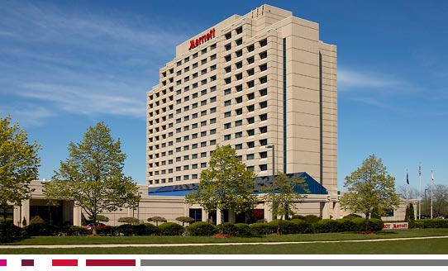
Troy Marriott Hotel
The

Friday, July 16, 2010
7:30 am - 8:00 am Registration, continental breakfast exhibits

Evangeline Pizarro MD⁷⁰, moderator
8:00 am - 8:40 am Selected Update Topics in Cardiology 2010
Renato Ramos MD⁶³
Director, Interventional Cardiology
Royal Beaumont Hospital, Detroit Troy, MI
8:40 am - 9:20 am Anesthesia and Obesity
Roberto Kong MD⁸⁵
Director, Anesthesiology, Kettering Anesthesia Associates
Wilson Memorial Hospital, Sidney OH
9:20 am - 10:00 am Currents and Curiosities of Asian Pacific Blood Banking
Linda Tamesis MD⁸⁵
Professor and Chair, Department of Pathology
FEU-NRMF Institute of Medicine, Quezon City
10:00 am - 10:40 am Break, products, poster and alumni arts exhibit

Pete Florescio Jr MD⁷⁵, moderator
10:40 am - 11:20 am Selected Update Topics in Medical Surgical Missions
Edmundo F Relucio MD⁶⁴
CEO & President, Rennaissance Simons’ Charitable Foundation Inc
11:20 am - 11:30 am Introduction of 4th Jesus B. Nolasco MD Memorial Lecture
Edmundo F Relucio MD⁶⁴
Chairman, Jesus B. Nolasco MD Memorial Lecture Committee
11:30 am - 12:30 pm Fourth Jesus B. Nolasco MD Memorial Lecture
Congestive Heart Failure 2010
Ray Sandoval MD⁶⁰
Chief of Cardiology, VA Southern Nevada Healthcare System
Professor of Medicine, University of Nevada School of Medicine
12:30 pm - 4:00 pm Break, product, poster and alumni arts exhibits



